With Comments

Services Associate
Program Guide by Schneider Electric

Table of Contents

I. Introduction 5
II. Program Overview 7
2.1 Program Goals 7
2.2 Pre-requisites 7
2.3 Validity 8
III. Services Associate 9
3.1 Rules of Engagement 9
3.2 Level Requirements 10
3.2.1 Revenue Goal 10
3.2.2 Sales Resources Staffing and Training 11
3.2.3 Delivery Resources Staffing and Training 11
3.2.3 Promotion of Schneider Electric Services 12
3.2.4 Procurement of Spare Parts and Components 12
3.2.5 Business Planning and Compliance Reviews 13
3.2.6 Sell Out Reporting and Information Sharing 14
3.3 Services Delivery Obligations: Field Service Bulletins 15
3.4 Benefits 16
3.4.1 Pricing and Discounts 16
3.4.2 Year-End Bonus 16
3.4.3 Opportunity Generation 17
3.4.4 Opportunity Management Through Schneider Partner Portal 18
3.4.5 Marketing Collaterals 18
3.4.6 Logo and Branding 19
IV. Specialty – IT Critical Power and Cooling 20
4.1 Introduction to IT Critical Power and Cooling Specialty 20
4.2 Eligibility 21
4.2.1 Product Installation, Start-up & Commissioning 21
4.2.2 Warranty 22
4.2.3 Specific requirements for InRoom Cooling 23
4.3 Schneider Electric Offer for Life Cycle Services 23
4.4 Service Offer Description 24
4.4.1 Concurrent Services 24
4.4.2 Non-Concurrent Services 25
4.5 Sales training Requirements 28
4.5.1 Training Description 28
4.6 Pricing and Discounts 29
4.7 Key Performance Indicators for Services Sales 29
4.7.1 Asset Track Rate (ATR) 30
4.7.2 Warranty Capture Rate (WCR) 30
4.7.3 Contract Renewal Rate (CRR) 30
4.8 Technical Training Requirements 30
4.8.1 Description 30
4.8.2 Schneider Electric Policies and Procedures Training 31
4.8.3 Training Curriculum for Power Products 33
4.8.4 Training Curriculum for InRow Cooling Products 33
4.8.5 Training Curriculum for InRoom Cooling Products 35
4.8.6 Registration for Training and Applicable Charges 37
4.8.7 Proficiency Field Validation 37
4.8.8 Field Experience 38
4.8.9 Maintaining Proficiency 38
4.9 Key Performance Indicators for Service Performance 38
4.9.1 Customer Satisfaction 39
4.10 Tools & Software Licenses 39
4.10.1 Communication Equipment 40
4.10.2 Safety Equipment 40
4.10.3 MAINT Tool 41
4.10.4 TUNER Tool 41
4.10.5 Tool License Fees 42
4.10.6 Software Tool Eligibility and Usage 42
4.11 Task Completion Notifications 42
4.12 Technical Escalations 42
4.13 Service Delivery Fees 43
4.13.1 Activity Notification & Payment Process 43
Appendix 1: Schneider Electric Partner Program Communication Guidelines 45
Appendix 2: Sell-Out Reporting and Asset Declaration 46
Appendix 3: TUNER Software License Renewal Process 48
Appendix 4: Product Registration Guidelines 49
Appendix 5: RMA Process for Equipment Under Factory Warranty 51
Appendix 6: Warranty Claim on Spares Supplied Without Labor 52
Appendix 7: Partner Claims 53
Appendix 8: Monthly Claim Form 54
Appendix 9: Training Booking Form 55

The content of this document is subject to change at Schneider Electric’s sole discretion and without notice. The Partnershould therefore check the continued validity of these guidelines with the local Schneider Electric representative.

Introduction

Welcome to theServices Associate Program by Schneider Electric: you havebeen invited to join Schneider Electric’s comprehensive Channel Program focused on delivering best-in-class services to our customers.
As the global specialist in energy management and automation, Schneider Electric creates connected technologies that reshape industries, transform cities and enrich lives.
At Schneider Electric, we call this Life Is On.
To properly support the above statements, it is imperative for us to view our services organization as key to our success. We have therefore developed a set of sales, marketing, and services policies which are designed to drive the way we do business in the areas of go-to-market, service management, and fulfillment.
At Schneider Electric, we believe that customer satisfaction does not merely result from selling high-quality products that are easy to service and maintain. We must also be adept at promoting, selling, and delivering those services to customers at the right time and place, in a safe and professional manner,and with the most competent and experienced personnel. These competencies, expertise, and best practices are key success factors we want to transfer to our partners. As a focused channel partner for Schneider Electric, you are uniquely positioned to address this market and grow revenue by selling and jointly deliver the appropriate Schneider Electric branded services.
In return, you will be eligible for preferential pricing and discounting, financial rewards, access to sales and technical trainings, tools, and a dedicated partner branding with worldwide recognition.
Eligibility to the Services Associate Program is by invitation only: nominated channel partners must have achieved a specific certification level in their corresponding Schneider Electric product channel program. To be part of this program, the partner has also to be selected by their Schneider Electric Channel Sales representative based on joint business potential and thepartner’s willingness to invest in training resources with appropriate skills. By default, this program is only made available to Schneider Electric’s most loyal and successful certified partners.
This document outlines various elements of the Services Associate Program. It will also familiarize the partner with the program’s processes, procedures, and the means by which the partner’s organization will be able to play an important part in contributing to joint revenue growth, servicequality, and customer satisfaction.
This document and the program terms detailed are applicable in South Africaonly.
About Schneider Electric
Schneider Electric is leading the Digital Transformation of Energy Management and Automation in Homes, Buildings, Data Centers, Infrastructure and Industries. With global presence in over 100 countries, Schneider is the undisputable leader in Power Management Medium Voltage, Low Voltage and Secure Power, and in Automation Systems. We provide integrated efficiency solutions, combining energy, automation and software. In our global Ecosystem, we collaborate with the largest Partner, Integrator and Developer Community on our Open Platform to deliver real-time control and operational efficiency. We believe that great people and partners make Schneider a great company and that our commitment to Innovation, Diversity and Sustainability ensures that Life Is On everywhere, for everyone and at every moment.
www.schneider-electric.com

Program Overview

Our joint ambition is to go beyond our standard practices by having a strong focus on value-added services and promoting targeted offers to customers that are currently not addressed to their full potential. By sharing the efforts and the investments, Schneider Electric and the Partner expect to grow their revenue, improve their margins, and expand their footprint on the market.

2.1 Program Goals
The Services Associate Program goals are as follows:
- Provide an opportunity for the Partner to increase its reach and revenue by the resell ofSchneider Electric services;
- Create additional revenue for the Partner through subcontracting of specific service activities by Schneider Electric;
- Allow the Partner to differentiate itself by participating in Schneider Electric enablement paths, so it can build breadth and depth of services to be deliveredwith efficiency and effectiveness to its customers, from systems’ installation and commissioning through optimization and highly performing operations, to maintenance and recurring support contracts;
- Reduce channel services overlaps through clearly defined rules of engagement;
- Enable the Partner to resell Schneider Electric Services and position itself as a Associate of such services to the market;
- Ensure that all customers receive an optimal level of services delivery and support;
- Promote specialties to recognize the Partner’s skills and competencies on specific servicesoffers;
- Manage the end-customer commercial relationship from promotion up to delivery jointly with Schneider Electric;
- Receive feedback and input from partners on offers and programs to feed technological trends and innovation projects;
- Increase the Partner’s profitability through attractive financial incentives.

After completing the program requirements, the partner will be deemed anAuthorized Services Associateby Schneider Electric and eligible to the program benefits.

2.2 Pre-requisites
The Partner must have achieved and maintained a specific partnership level as part of at least one of the product partnerships proposed by Schneider Electric (APC Channel Partner, SE Licensed Panel Builder, SI Alliance Partner, EcoXpert, etc) relevant to a Services Associate specialty and have a signed active Services Associate agreement with Schneider Electric to be eligible for the Services Associate Program. Detailed requirements are described in the Specialty chapters of this document.
From the date of notification by Schneider Electric of eligibility to one of the Services Associate Programmodels, the Partner will start at the Registered level and will havethree months to complete all requirements to maintain eligibility to the program and reach the Authorized level. Benefits of the program are conditioned by the Partner’s compliance to the requirements and key performance indicators (KPIs) listed in this program guide.

2.3 Validity
Qualifications, achievements, and access to specific tools and/or resources are valid for a limited time and will require regular updates or requalification or fees during the lifecycle of the partners’ membership to the program.
The criteria for updates or requalification will be defined in the relevant specialties, and the below validity periods are applicable to this program:
Type | Description | Validity
Individual Qualifications | Qualifications obtained by individuals following trainings and/or examinations by Schneider Electric | 2 years
Level of Partnership | Eligibility to Authorized level of partnership is reviewed yearly | 1 year
Revenue Requirement | Revenue target to comply to program requirement is set and reviewed yearly | 1 year

Services Associate

Over the last decades, Schneider Electric has tailored high-value services based on its products and technologies. These services are aimed at enhancing customer experience and extending usability and availability with state-of-the-art energy efficiency best practices, in a world that has evolved from products toservices and digital-oriented solutions.
In order to accelerate the reach of our offer, Schneider Electric wants to associate specifically identified partners to reach new business levels and share the rewards. For this purpose, the Services Associate Program will help the Partner understand the breadth and the value of Schneider Electric services portfolio, learn the best practices in promoting and selling those services, and increase its revenue and profits through targeted financial incentives as well as services execution.
Through a balance of requirements and benefits, rights and obligations, the Services AssociateProgram brings the full strength of Schneider Electric worldwide services organization to assist the Partner in opening new revenue streams and business potential.Schneider Electric expertise on its products life cycle is shared with the Partner to convert the information of the customers’ installed base into services opportunities.
As a ServicesAssociate, thePartner should not propose similar services on Schneider Electric products, whether delivered by the partner itself or a third party, to its customers.

3.1 Rules of Engagement
Schneider Electric is aiming at maximizing its market coverage and for this purpose has developed different go-to-market strategies. As a large multinational company and a leader in its markets, Schneider Electric has established direct relationships with a number of customers around the world, as well as a vast network of channel partners who are in turn addressing an even larger number of customers. As a part of this network, the Partner has a key role to play in addressing the market and meeting customers’ requirements.
Establishing a clear commercial policy is key to a successful partnership between Schneider Electric and the Partner. Enforcing this policy through clear rules of engagement is the cornerstone of a successful and beneficial relationship between Schneider Electric and the Partner, providing clarity and visibility to our approach to the market and how we are cooperating for mutual success.
The purpose of this program is to expand our joint market reach by targeting specific customers with the appropriate value proposition, thus maximizing revenue and profitability for both parties.
As such, existing direct business between Schneider Electric and end customers should not be affected by the Partner’s participation into this program. In particular,Schneider Electric has established at the global and country level a list of customers (“house accounts”) with whom a direct go-to-market model is applied and the Partner is not expected to actively pursue sales opportunities on those accounts. This list, updated on a regular basis, will be communicated to the Partner at the time of joining the program and then upon any modification. Pricing, discounts, and other specific conditions described in the present Program Guide will therefore not be applicable if the Partner decides to engage in reselling Schneider Electric services to these customers.
In specific circumstances, Schneider Electric may elect to fulfill the services transaction through the Partner, at conditions that will be specified and agreed on each occurrence.
The Partner is encouraged to actively pursue services opportunities as part of the present program on two categories of assets:
- Assets newly sold by the Partner to customers not listed as house accounts, starting from the signature date of the Services Associate Agreement, and,
- Assets previously sold by the Partner to customers not listed as house accounts, prior to the signature date of the Services Associate Agreement, that are not under a valid service contract with Schneider Electric and to whom Schneider Electric did not sell any service directly for the past 24 months.
Schneider Electric does not recommend that the Partner,in the framework of our collaboration, actively engages in pursuing services opportunities on assets it did not sell, unless by specific prior agreement with Schneider Electric.
As a subcontractor of Schneider Electric for services activities for which the Partner has achieved the appropriate qualification, the Partner will act upon request and on behalf of Schneider Electric where and when instructed by Schneider Electric, and in compliance with the expectations of the services sold and Schneider Electric’s best practices.
These rules of engagement as well as the list of preferred targeted customers should be reviewed jointly by Schneider Electric and the Partner during regular business reviews.

3.2 Level Requirements

3.2.1 Revenue Goal
Eligibility to the Services AssociateProgram and its corresponding benefits is strongly tied to the ability of the Partner to generate additional revenue, for itself and for Schneider Electric, through the promotion of Schneider Electric services on the market, in particular on the Partner’s installed base.
The specific pricing and discounting conditions provided to partners participating in the program are based on minimal Schneider Electric annual revenuefrom services purchased by the Partner. Minimal revenue is based on the Partner’s country location/territory as defined in the agreement with Schneider Electric.
In South Africa, the yearly services revenue threshold to become an AuthorizedServices Associate is ZAR1 500 000.
This threshold value is valid prorata temporis, based on actual date of onboarding within the Services Associate Program and on transfer prices of services to the Partner.
Eligible services are described on https://www.schneider-electric.co.in/en/work/services/field-services/index-new.jsp
Schneider Electric and the Partner will agree on a yearly revenue target to be included in the joint business plan that may exceed the stated minimum. Failure to achieve the minimal revenue at the time of the annual review of the partnership may be a cause for termination of the membership in the program.

3.2.2 Sales Resources Staffing and Training
Promotion of Schneider Electric services requires both dedicated and qualifiedresources: selling the appropriate services value proposition to a customer is the result of having the right sales resources with the appropriate skillset.
The Partner acts as an extended sales force of Schneider Electric and therefore must ensure its sales resources are able to deliver the correct message to its customers.
The Partner will appoint one person in its organization who will act as single point of contact for all services sales related topics and correspondingly Schneider Electric will appoint a services channel representative for the Partner.
Where available, the Partner single point of contact will register the Partner at the Schneider Electric’s Partner Portal (https://www.apc.com/us/en/partners-alliances/) and ensure all staff members involved in the present program are also registered and associated to the Partner’s account.
Once the Partner representative has completed all training requirements for the chosen specialty, he/she will be qualified for this specialty as: Proficient.
As and when enhancements are brought to the Services Associate Program, Schneider Electric may introduce additional competency levels with specific requirements.
For each specialty that the Partner engages in and based on the partner’s country location/territory as defined in the partner agreement with Schneider Electric, the requirements for qualified staff are a minimum of two Proficient individualsqualifiedby specialty.
Specific training and qualification requirements by specialty are listed in the appendix of this guide. One individual may complete the qualification requirements for several specialties.
As a recommendation, in the same way that the services revenue goal is a key feature of this program, qualified as Proficient sales individualsshall have a specific Schneider Electric services revenue target in their goals and corresponding financial incentives. If goal setting is not exclusively focused on services revenue, then achieving the services revenue target should be conditional to overall revenue target achievement.

3.2.3 Delivery Resources Staffing and Training
As a Services Associate, the Partner will have access to a range of factory technical trainings allowing its staff to deliver a selected number of service activities using Schneider Electric’s know-how, tools and best practices to bring a defined and consistent user experience to the market upon request of Schneider Electric.
Because it is delivering a service activity part of a Schneider Electric service offer, the Partner has an obligation to ensure that its services delivery workforce is trained on and maintains the appropriate level of technical qualification as defined by Schneider Electric, as well as comply to all applicable laws and regulations of the country. Individuals trained for service delivery will be referred to as Partner Technician.
Once an individual being the Partner Technician has completed all training requirements for the chosen specialty, he/she will be qualified as: Proficient
As and when enhancements are brought to the Services Associate Program, Schneider Electric may introduce additional qualification levels with specific requirements.
For each Specialty that the Partner engages in and based on the Partner’s country location/territory as defined in the Partner agreement with Schneider Electric, the requirements for qualified Partner Technicians are a minimum of one (1) Proficient individual by product line or category for a given Specialty.
Specific training and qualification requirements to reach the Proficient qualification by product line or category for each Specialty are listed in the related appendix of this guide. One individual may complete the qualification requirements for several product lines or categories in one or more Specialties.

3.2.3 Promotion of Schneider Electric Services
It is expected that the Partner will actively promote Schneider Electric services to itscustomers through regular contacts and marketing campaigns and events. The Partner will use materials provided by Schneider Electric to ensure visibility of Schneider Electric brand and its impact on the market. Co-branding will be possible as per the guidelines included in this guide.

3.2.4 Procurement of Spare Parts and Components
It is highly recommended that the Partner purchases spare partsmanufactured and/or sold bySchneider Electric, including but not limited to replacement batteries, to ensure that quality standards of the parts are met, avoid fakes and counterfeited parts, and benefit from parts obsolescence policy of Schneider Electric.
The Partner shall stock appropriate levels of spare parts to satisfy customer demands according to their installed base and following recommendations by Schneider Electric. Should a spare part be revised / upgraded,Schneider Electric will, upon the return of an obsolete part in its original packaging, replace it free of charge.
Schneider Electric discharges its responsibility on all repairs carried out where Schneider Electric original parts are not used.

3.2.5 Business Planning and Compliance Reviews
A yearly review of the Partner’s compliance to the program requirements will be held with the partner and led by Schneider Electric channel representative in last quarter of each year to assess the performance of the past year. During this review, compliance to program requirements as well as mutually agreed targets will be reviewed and the results will determine eligibility for the following year. If changes are introduced, a grace period for compliance will then be agreed upon, at the end of which another review will be held to confirm or reject participation in the program.
In addition, it is highly recommended that a quarterly review plan is established between the Partner and the Schneider Electric channel representative from joining the program. During each quarterly meeting, the following topics will be reviewed (but not limited to):
- Year-to-date services revenue vs. target;
- Pipeline and opportunity status;
- Marketing activities and initiatives;
- Account planning and mapping;
- Joint initiatives followup;
- Training and certification followup;
- Services Sales &Delivery KPIs by specialty;
- Customer satisfaction;
- New offer introductions;
- Required support from Schneider Electric;
- Eligible benefits review;
- Corrective action plans as and when necessary.
Regular meetings should be held to review day-to-day business as follows:
- Daily is focused on transactional;
- Weekly includes insight on the partner’s pipeline and forecasting, as well as any open customer-related actions;
- Monthly planning and updates;
- Quarterly marketing planning and business review;
- Annual business planning;
- Pipeline and forecasts.

Pipeline and Forecasting
A review of how to manage the sales relationship and focus beyond the transactional opportunities, using tools and communications for building and maintaining a healthy relationship between the partner and Schneider sales opportunity management. Recognize the “who, what, why, and how” of both effective pipeline and forecasting.

Annual Marketing Plan
The purpose of the marketing plan is to facilitate collaborative strategic marketing planning between Schneider Electric and the partner. The plan focuses on activities to help drive Schneider business and measure the return on investment. Schneider provides the partner with the tools and materials through the Schneider Electric PartnerPortal.

Business Planning
Review elements and timeline for business planning and follow-up. The objective is to conduct an extensive review of industry best-in-class business planning.

Conducting Business Reviews
Business reviews are key to ensuring that both parties are meeting their commitments and that the results are according to plan. Reviews should take place quarterly – preferably face to face. Schneider recommends that the partner works closely with its Schneider channel representative for support and guidance.

3.2.6 SellOut Reporting and Information Sharing
Ensuring that correct and detailed end-user data are captured is key to successful business planning and efficient opportunity generation. On a monthly basis, the partner will report all product sales including detailed information on the product and enduser, as per the process described in Appendix 2. This is a mandatory criterion for compliance to the program.
To maximize the efficiency of the opportunity generation process, the partner also has the ability to register previously sold Schneider Electric products through a number of tools, mobile apps, and websites to update Schneider Electric’s database. However, for bulk upload of information, the partner has a choice of providing information using a spreadsheet format.
By following the asset data template provided by Schneider Electric, the partner ensures fast processing of the data and generation of services opportunities.
Getting the products registered with the correct end-user information enables a lifecycle management of customers installed base and provides the partner with recommendations on services sales, based on the products. It also enhances customer experience by enabling the registered customers to benefit from all value-added information and support relevant to their product base.

3.3 Services Delivery Obligations: Field Service Bulletins
Along the lifecycle of its products, Schneider Electric may publish Information Bulletins or Field Service Bulletins (FSB) alerting on issues or potential issues affecting one or more of its product lines, including detailed corrective actions.
This information will be shared with the Partner either through its local Schneider Electric representative or via the Partner Portal or any such digital tool made available by Schneider Electric to the Partner. It is the Partner’s responsibility to inform its impacted customers, as well as proceed to implement the recommended corrective actions as described in the FSB and in line with the FSB Severity Matrix below.
It is the Partner’s responsibility to ensure all information about installed products and related end-user information is shared with Schneider Electric in a timely manner to enable Schneider Electric to provide relevant information to the Partner.
FSB may include, but not limited to, part replacement, code or firmware upgrades. Depending on the nature and severity of the issue, Schneider Electric may or may not provide free of charge replacement part or component, and/or a compensation fee for completion of the FSB. Conditions will be specified in the relevant FSB documentation.
In case the Partner does not have qualified personnel with the appropriate qualification relevant to the impacted product and as described in the relevant specialty chapter of this guide, the Partner Schneider Electric will need to engage at its own cost either Schneider Electric or a Schneider Electric authorized party to complete the FSB.
FSB Severity Matrix:
Severity | Expected Action
5 – Safety Related | Requires immediate action. Partner shall contact customer to inform about the issue and agree on a date for implementation of the recommendations
4 – High / Significant | Requires immediate action. Partner shall contact customer to inform about the issue and agree on a date for implementation of the recommendations
3 – Moderate / Significant | Partner shall contact customer to inform about the issue and agree to implement during earliest of next planned visit (preventive maintenance) or unplanned (break & fix)
2 – Low / Insignificant | Partner shall contact customer to inform about the issue and agree to implement during earliest of next planned visit (preventive maintenance) or unplanned (break & fix)
1 - Minor | Partner shall contact customer to inform about the issue and agree on implementation at customer’s convenience

3.4 Benefits
Benefits listed below are generic to the Services AssociateProgram. Additional benefits may be included in the specific specialties.
Benefits | Not in the program | Services Associate
Benefits | Not in the program | Registered | Authorized
Services Sales Training |  | Yes | Yes
Exclusive Pricing |  | Yes | Yes
Marketing Tools & Collaterals |  | Yes | Yes
Opportunity Generation |  | Yes | Yes
Schneider Electric Partner Portal |  | Yes | Yes
Services Delivery Training |  | Yes | Yes
Services Delivery SW Tools (Ex: Tuner) |  | Yes | Yes
Maintenance Delivery SW Tool (Ex: MAINT) |  | Yes | Yes
Technical Escalation |  |  | Yes
Rebates and Bonuses |  |  | Yes
Service Delivery Fees |  |  | Yes
Badging & Branding |  |  | Yes
Exclusive Offers |  |  | Yes

3.4.1 Pricing and Discounts
As a member of the Services AssociateProgram, the Partner is eligible to specific pricing and discount schemes to reflect its commitment to grow services revenue and the investment made to support the sales effort.
Specialties detail discounts based on compliance with the specific requirements.
In case the Partner requires a discount higher than a standard discount mentioned in the program guide to close a services deal, it is required to submit a request through the Schneider Electric channel representative including appropriate justifications and, without exception, to:
- Register the opportunity through the Opportunity Registration Processavailable in the country and made available to the Partner by Schneider Electric;
- Provide full details of the enduser (name, address, contact information) for the services as well as all related Schneider Electric products to which the services are related.

3.4.2 Year-End Bonus
In order to encourage the Partner to overachieve the goals set jointly with the Schneider Electric channel representative, Schneider Electric proposes to reward the best performing partners through an attractive year-end bonus scheme.
This bonus is based on yearly performance and the Partner is eligible if:
- Yearly revenue at the end of the fiscal year is ZAR 1 or more above the agreed target;
- Partner is compliant with the program and applicable specialty(ies) requirement(s) and KPIs.
The bonus is then calculated as a percentage of the yearly revenue (Schneider Electric transfer price) and will be paid on the second month of the next fiscal year.

Achievement of theyearly target | Bonus (% of achieved revenue)
100% < x $≤$ 110% | 1 %
110% < x $≤$ 120% | 1.5 %
120% < x $≤$ 130% | 2 %
130% < x $≤$ 150% | 2.5 %
Above 150% | 3%

This bonus cannot be cumulated with Marketing Development Funds (MDF) based on services revenue if such a MDF is available and already included in the product channel program the Partner is part of, such as the APC by Schneider Electric Channel Program.
Other incentives may be available depending on specialties and/or specific initiatives or promotions by Schneider Electric.

3.4.3Opportunity Generation
Schneider Electric has used its in-depth know-how of the energy distribution industry and its experience as a world-leading vendor to develop best-in-class services opportunity generation systems. As a member of the Services Associate Program, the Partner can benefit from this process and associated tools to quickly and easily identify which service offers can be targeted at which customers, along with the appropriate value proposition messages, marketing and sales collaterals, and attractive pricing.

The premises for success are based on:
- Accurate installed base information shared between the Partner and Schneider Electric and,
- Clear rules of engagement that prevent any conflict between the Partner and Schneider Electric or other partners.
Within Schneider Electric’s installed base database, the capability to assign a Partner of Referenceto the level of the individual asset allows clear identification of which Partner is the appropriate beneficiary of system-generated opportunities.

3.4.4Opportunity Management Through Schneider Partner Portal
Along with the opportunities declared directly by the Partner through the Opportunity Registration Process, system-generated opportunities are assigned to the Partner in Schneider Electric Customer Relationship Management tool based on Salesforce.com technology.
The Partner is granted access to the Customer Relationship Management tool through the Partner Opportunity Management Portal either as a stand-alone access or through the Schneider Electric Partner Portal (https://Partner.schneider-electric.com/) if available in the Partner’s country. This way, the Partner can be confident that the opportunity is not made available to Schneider direct services sales force nor to other partners. It is expected that the Partner will actively work on the opportunities assigned to achieve a successful conclusion and conversion into orders. Please note that opportunities must be accepted or rejected within ten days of being assigned to the Partner. After this time, they will automatically be reassigned to Schneider Electric.
Although the Partner has the first right of refusal to any opportunity assigned by Schneider Electric, failure to actively pursue an accepted opportunity for a period of three months will result in Schneider Electric’s possibility to take over the related opportunity and handle it at its sole discretion and without compensation.
It is therefore in the Partner’s best interest to share with Schneider Electric all information about serviceable products installed at the Partner’s endusers that Schneider Electric may not be aware of. Thanks to the robust process mentioned earlier, the Partner ensures that subsequent services opportunities are funneled for its sales force to handle.
The Partner and the Schneider Electric channel representative will review together the installed base information during account mapping sessions to ensure all parties are aligned on the engagement model and the route to market.

3.4.5Marketing Collaterals
Brochures, data sheets, customer success stories, and presentations are available on the Schneider Electric Partner Portal (https://www.apc.com/us/en/partners-alliances/) if available in the Partner’s country. If this portal is not available in your country and/or you require original printed versions of these materials for events or customer meetings, they are available upon request from the Schneider Channel Sales and Marketing teams for your region.

3.4.6Logo and Branding
Upon completion of the first specialty requirements, the Partner will officially become an Authorized Services Associateby Schneider Electric for the duration of the calendar year, provided continuous compliance to the program is secured.
To materialize this achievement, the Partner will receive an accreditation letter stating the Partner’s capacity to promote and resell Schneider Electric services as well as its proficiency to deliver services. This letter can be shared with any existing or potential customers to demonstrate the Partner’s participation in the program.
In addition, the Partner will be allowed to display the appropriate badge on its published documents, whether physical or on the web, as per guidelines described in Appendix 1.
In case the Partner is no longer part of the Program, it shall immediately stop presenting itself as an Authorized Services Provider nor display the related badge.
Badge example:

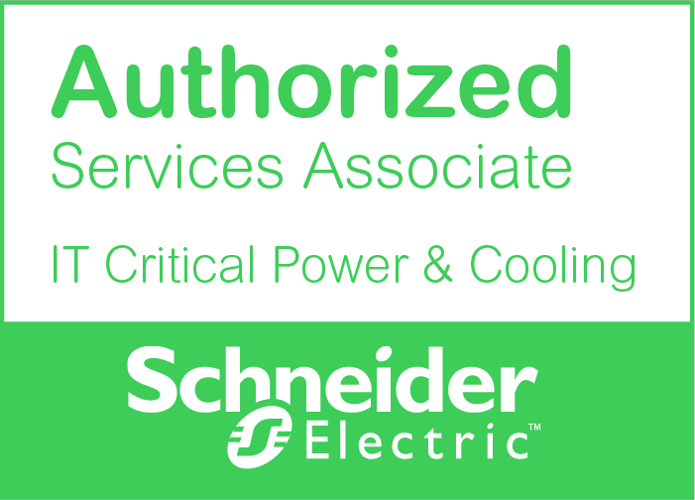

Specialty –
IT Critical Powerand Cooling

4.1 Introduction to IT Critical Power and Cooling Specialty
As a leading provider of critical power and cooling solutions, Schneider Electric has designed a range of services allowing customers to fully benefit from the features and availability of their Schneider Electric equipment based on industry best practices, superior skills and efficient tools.
From single-phase individual protection devices to full-fledged three-phase uninterrupted power supply systems, and in-row cooling for IT racks to full in-room cooling solutions, Schneider Electric encourages the partner to invest in selling high-value services and expands its expertise by acquiring the technical know-how to deliver services on-par with Schneider Electric best practices and in line with the customers’ expectations.
Through this specialty, the Partner sales team will acquire the appropriate knowledge to successfully sell the value of Schneider Electric service offers, respond to the customers challenges and utilize the appropriate marketing and sales collaterals to boost their services business.
In parallel, the Partner technical team will be granted access to in-depth technical trainings following the same path as Schneider Electric Field Service Representatives as well as proprietary tools allowing them to perform service activities to the same level as their Schneider Electric counterparts and on behalf of Schneider Electric. This tight alignment between the Partner and Schneider Electric guarantees the continuity and the excellence of the customer experience with Schneider Electric services.
The more technical knowledge & skills are acquired by the Partner team, the more Schneider Electric can engage the Partner to deliver on a large portfolio of service activities, therefore maximizing its revenue generation. Those activities may include:
- Installation, assembly, start-up & commissioning of new products;
- On-site fault diagnosis and part identification;
- Preventive maintenance;
- Break & fix activities, including failed part replacement;
- Microcode or firmware upgrades.
Each engagement by Schneider Electric will imply a notification to the Partner including a Work Order Number, the activity description, product and end-customer details. After completion, the Partner will submit the relevant activity reports and invoice to Schneider Electric to receive payment.
Regular business reviews will ensure that the Partner sees a return on its investment on the skills of its sales and technical teams through joint business development and marketshare capture.

4.2 Eligibility
In addition to the generic requirements to the Services Associate Program described in Chapter III, partners willing to engage in the IT Critical Power and Cooling specialty must comply with the following prerequisites:
- Achieve and maintain Premier or Elite partnership level in the APC Channel Partner Program (https://www.schneider-electric.com/en/partners/it-resellers/)
- Meet the minimum annual services revenue of ZAR 2 000 000 (amount invoiced by Schneider Electric to the Partner for the specified services)
- Meet the requirements set in the Services Delivery Capability Assessment
- Agree to qualify to Proficient level a minimum of two people as per the Sales curriculum
- Agree to qualify to Proficient level a minimum of one person as per the Technical curriculum

Any exception should be agreed by Schneider Electric and documented in writing and isvalid for one year only.

4.2.1 Product Installation, Start-up & Commissioning
Products purchased by the Partner directly or indirectly from Schneider Electric may or may not include the installation and/or the assistance to start-up and commissioning as a feature or requirement. In all cases, as a Services Associate, it is the responsibility of the Partner to ensure the product installation, start-up and commissioning are performed according to Schneider Electric guidelines and best practices.
Depending on the product, such activity shall be completed by a Partner Technician employee who has achieved and maintained the Proficient qualification as detailed in the relevant specialty chapter of the present guide. For products including installation and/or the assistance to start-up and commissioning as a feature, Schneider Electric will compensate the Partner with a flat fee as per the matrix published and regularly updated by Schneider Electric.
Payment of the fee is subject toreception by Schneider Electric of the detailed installation report for the product including information as detailed in Appendix 2: Sell-Out Report & Asset Declaration as well as of the corresponding invoice.
For products not including installation and/or the assistance to start-up and commissioning as a feature, the Partner will also provide a detailed installation report upon completion of the activity as per the templates provided by Schneider Electric.
The Partner should notify Schneider Electric no later than 10 working days following the actual installation and/or commissioning of the product.
In case the Partner does not have personnel with the appropriate qualification relevant to the impacted product and as described in the relevant specialty chapter of this guide, the Partner will need to engage at its own cost either Schneider Electric or a Schneider Electric authorized party to complete the product installation, start-up or commissioning.

4.2.2 Warranty
For all products sold by and installed and/or commissioned by the Partner, the Partner is expected to offer to its customers a warranty that is equivalent or superior to the standard Schneider Electric warranty (as available on http://appropriate-URL.schneider-electric.com). [NOTE: if the warranty terms are not published on the local SE website, we may include them as an appendix in this guide]
Schneider Electric will offer part or component exchange (Return to Factory) as well as remote assistance to the Partner as available in the country for the duration of the factory warranty but will not include any on-site activity.
It is the responsibility of the Partner to perform any service activity required during the warranty period, by an individual who has achieved and maintained the appropriate Proficient qualification as detailed in the relevant specialty chapter of the present guide.
In case the Partner does not have qualified personnel with the appropriate qualification relevant to the impacted product and as described in the relevant specialty chapter of this guide, the Partner will need to engage at its own cost either Schneider Electric or a Schneider Electric authorized party to complete any corrective activity as covered by the warranty.
All defective parts replaced during the warranty period should be kept at the Partner premises for a minimum duration of six (6) months. Schneider Electric reserves the right to request at any time that the Partner make the parts available for inspection within this period.

4.2.3 Specific requirements for InRoom Cooling
InRoom Cooling solutions often require specific skills and experience beyond the usual scope of companies involved in the datacenter world. For this reason, Partners wishing to achieve qualification on servicing our InRoom Cooling products must, in addition to the eligibility criteria described above, have achieved the Cooling Premier program requirements.
The program details are available on Schneider Electric’s Partner Portal on https://www.apc.com/us/en/partners-alliances/
For more information, please contact your Schneider Electric Channel Representative

4.3 Schneider Electric Offer for LifeCyce Services
Schneider Electric’s comprehensive services solutions provide answers to all our customer needs.
The Partner will have access to Schneider Electric expertise, competencies, and support for building, industry, power, and data center infrastructure.
Schneider Electric will enable the Partner to become a trusted advisor to promote and sell the power and cooling services offer. In addition, the Partner’s capacity to act as a subcontractor for the delivery of a portfolio of service activities will uniquely position it on the market.
Schneider Electric is committed to providing services that dramatically simplify the process of planning, deploying, and operating the most efficient and reliable facilities of our endusers.
Hence, Schneider Electric considers the asset management lifecycle from planning and installing, through operating and optimizing up to renewing.
All services are designed to support products and applications, including UPS units, power distribution andcooling solutions, racks and accessories, security and environmental solutions, and software. Schneider Electric also provides services such as project management, assessments, and facility operations.
Every facility experiences growth, changes, and new business requirements through its life cycle that make it necessary to expand, consolidate, or deploy new technology and equipment.
The graphic below illustrates the stages of the infrastructure life cycle. Whichever stage the customer is at, Schneider Electric has the expertise, support, and services to help the customer prepare, design, acquire, implement, maintain, and upgrade their mission-critical equipment.

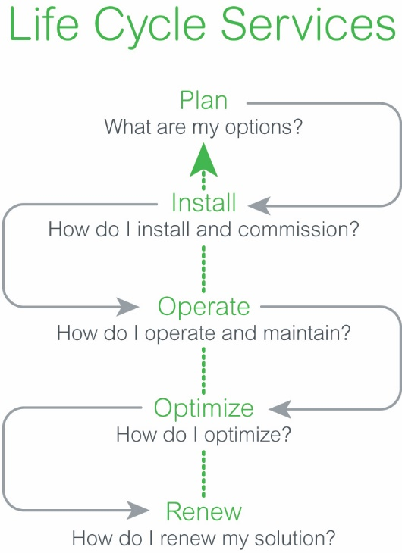

5
4
3
2
1
Plan | Install | Operate | Optimize | Renew
Our experts can help you plan, define, and design the right solution for increased efficiency and availability. | This stage includes installation and commissioning services such as assembly and startup, project management and site coordination and network integration services. Startup and assembly services are available for all 3P, ancillary, and cooling products as well as 1P Smart-UPS On-Line and Symmetra LX products. | Minimize your solution uptime and performance with advantage plan service packages that keep your equipment running efficiently and maintain maximum availability while protecting your investment. | Our solution experts and remote monitoring systems will provide proactive and tailored recommendations that are needed to reduce risks and improve solutions performance and reliability. | Schneider Electric enables you to increase performance and flexibility while controlling the costs of aging infrastructure.

4.4 Service Offer Description
Schneider Electric’s service offer is divided into two families:
- Concurrent services: Service offers sold concurrently with the products or solutions, literally on the same product order.
- Non-concurrent services: Service offers sold non-concurrently, meaning after the product has been sold. Generally speaking, a non-concurrent service is sold when the factory warranty is over.

4.4.1 Concurrent Services
Assembly Services – Three Phases and Cooling
This service includes unpacking, inspection, positioning and assembly of all components of the solution.
Schneider Electric personnel, or the Partner personnel if subcontracted by Schneider Electric, will remove all packaging material to the customer’s disposal area. All labor and travel expenses are included.
Startup Service – One Phase, Three Phases,and Cooling
This service consists of verifying proper wiring of the system, energizing the hardware, and running diagnostic tests on the installed hardware to ensure it is functioning to the manufacturer’s specification. A basic operator training is provided. All labor and travel expenses within 50 km of a Schneider Electric office are included.
On-Site Warranty Extension Service – One Phase, Three Phase,and Cooling
This service provides an on-site extension to the factory warranty for three-phase and cooling equipment. This service must be purchased concurrently with the product and will take effect upon expiration of the factory warranty. On-site warranty extension is available in a one- or two-year term. Parts, labor, and travel expenses are included as well as a site inspection visit. Thenext business day is the standard on-site response time, upgrades to 8 hours and 4 hours are available within 50 km of a Schneider Electric office. This service is not renewable.
Extended Warranties – One Phase, InRoom Cooling
This warranty extends the factory warranty for a one- or three-year term. This service provides the delivery of replacement parts. No field engineer labor is included, 7x24 technical support is available in some locations.
EcoStruxure Asset Advisor –One Phase, Three Phase,and Cooling
EcoStruxure Asset Advisor is a vendor-neutral affordable 24x7 remote troubleshooting service that provides peace of mind and fast issue resolution, enabled by community-based chat with your own team or the Schneider Service Bureau, by monitoring your critical equipment insights and smart alarming directly to your smartphone – proactively minimizing downtime.
This service provides instant access to live sensor data via a mobile app to ensure visibility into the asset health and lifecycle, whether on premise or on the go. EcoStruxure Asset Advisor supports all types of UPS, power distribution units (PDU) and cooling equipment.

4.4.2 Non-Concurrent Services
Advantage Plans –Three Phase and InRow/InRoom Cooling
Advantage plans are provided for renewal of maintenance services. Advantage plans allow the customers to choose the options best suited to their needs and budget constraints.
• Advantage Plus plan provides a superior level of coverage that includes 7x24 technical support, bi-annual preventive maintenance visit, and next business day on-site response time. Labor and travel expenses are not included and parts are available at a discounted rate on time and materials.
- Advantage Primeplan provides 7x24 technical support, one bi-annual preventive maintenance visit, next business day on-site response time, and remote monitoring. Labor and travel expenses are included for emergency call outs, parts are available at a discounted rate.
- Advantage Ultraplan provides 7x24 technical support, one annual preventive maintenance visit, next business day on-site response time, and remote monitoring. Parts, labor, and travel are included.
- Advantage Maxplan is sold in conjunction with Advantage Plus, Prime, or Ultra plan and provides asset capacity trending and a data center health check. The data center health check consists of an asset management plan and an IT room audit.
- Upgrades to 8 hours and 4 hours are availablein certain areas – please consult you service representative for availability.

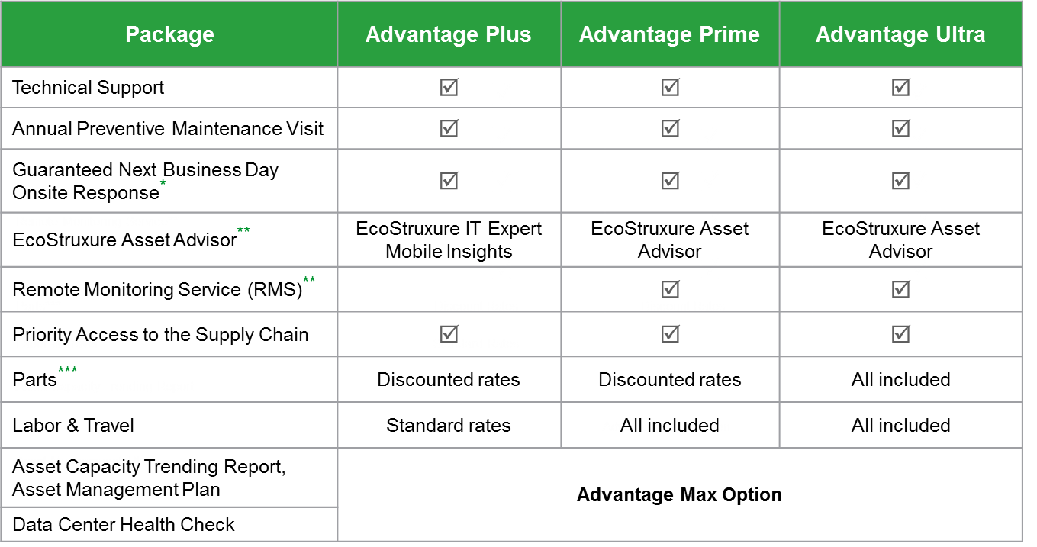
* Upgrades to 8-hour or 4-hour onsite response time and upgrade to 24 x 7 Preventive Maintenance Service may be selected where available.
** RMS is not available in all regions or on all products. See your Service Sales Rep for details. Replaced by EcoStruxure Asset Advisor where available.
** EcoStruxure Asset Advisor, formerly-known as StruxureOn, is not available in all regions or on all products. See your Service Sales Rep for details.
*** Batteries not included.
Table above is showing the scope of work overview for the Advantage contract offer.
Conditions for eligibility to Advantage Plans
For an asset to be contract-eligible, it must be under warranty (Factory warranty, Extended warranty, Advantage Service Plan) or with a warranty expired less than six (6) months ago. Once the service contract, factory warranty, or extended factory warranty has expired for more than six (6) months, it is required to purchase a Recertification Preventive Maintenance Visit/ Pre-Contract Audit before the unit is placed back under contract. Defective parts repair and/or replacement will be charged to the customer.
Recertification Preventive Maintenance Visit / Pre-Contract Audit– One Phase, Three Phases, InRow/InRoom Cooling
This service provides a comprehensive visual, environmental, mechanical (for Cooling), electrical inspection and baseline report of the to define the current status of critical systems that have been out of warranty/service agreement for a period greater than six (6) months. This service includes all labor and travel expenses. Periodic maintenance, remedial repairs, parts and replacement batteries are not included as part of this service offer.
This service identifies those product enhancements, upgrades and remedial repair requirements to be met before your system can be covered under a service agreement.
Preventive Maintenance (PMV) – One Phase, Three Phases, InRow/InRoom Cooling and Batteries
This service provides for bi-annual site visits designed to examine the status and health of your APC by Schneider Electric equipment. This service consists of performing both visual and electronic inspection of hardware to ensure the system is performing to technical and environmental specifications. Labor and travel expenses are included.
Battery Replacement Service – Non-Modular Product – Three Phases
This service provides a single site visit to replace the systems batteries and run diagnostics to ensure the system is functioning properly. Labor and travel expenses are included. Battery removal and disposal available at an additional cost. Batteries sold separately.
Battery Replacement Service (MBRS) – Modular Product – Single Phase (LX) &Three Phases
This service provides a single site visit to replace the system batteries. and run diagnostics to ensure the system is functioning properly. Batteries, labor, disposal, and travel expenses are included.
Modular Power Revitalization Service (MPRS) – Modular Product – Three Phases
Modular Power Revitalization Service provides a comprehensive on-site UPS revitalization service for modular UPS solutions. It is ideal for customers who want to extend the life of their modular UPS. UPS critical components, travel, labor, disposal expenses, and a one-year Advantage Ultra service plan are included.
Spare Part Catalogue – All Ranges
Spare parts catalogue is delivered and maintained by Service Supply Chain. This catalogue contains spare parts references for existing product ranges as well as phased out product ranges
Spare parts can be sold:
- Through time and material (T&M) process
- Directly to the Partner
Spare parts can be changed case by case through a proactive or break fix approach.

4.5 Sales training Requirements
The training program offers all partners skills and sales knowledge required to be able to sell the Schneider Electric IT Critical Power and Coolingoffer:

- Services Reseller, IT Critical Power and Cooling

Access the training curriculum through the Digital Partner Portal.

Once a Sales individual has completed all training requirements for this specialty, he/she will be qualified as: Proficient
Prerequisites: none

Hours of training required:
- Online training: 4 hours*
- In-class training: to be advised.

4.5.1 Training Description
How To Sell Service and Support Plans: Online training (15 minutes)
As a partner, you are a trusted advisor on behalf of Schneider Electric and customers look to you to promote a long-term relationship for the life of their equipment. One great way to enhance your customer relationships is to understand the value services bring to your customers, as well as your business. This course will discuss how to leverage your existing customer relationships to increase non-concurrent (after market) services sales and grow your services revenue incrementally.

Modular Battery Replacement Service Overview: Online training (15 minutes)
This training provides an overview of Modular Battery Replacement Service (MBRS). Modular Battery Replacement Service is designed to provide a hassle-free way to have your batteries refreshed. MBRS provides the enduser with a fixed price for on-site battery replacement which includes the OEM-approved batteries, on-site labor replacement service, and environmentally compliant removal/disposal of the old batteries.

Increase your Solution Sales by Selling Services – Part 1: Online training (10 minutes)
This course focuses on those services available for your customer to purchase at the same time as their equipment purchase (known as concurrent services) and includes the features and benefits of project services and installation services. Understanding them can help you increase your solution sales.

Electrical Risk Prevention: Online training (3 hours)
A course for electrical workers in Schneider Electric that serves as a co-requisite to classroom instruction about electrical safety.

The Five Phases of the Field Services Life Cycle: Online training (10 minutes)
The life cycle model of field services follows the life cycle of the solutions and assets of our customers. Get an understanding of this model: learn what needs customers have at each point of this cycle and how Schneider Electric addresses and responds to those needs. Knowing the life cycle of field services is essential to understanding and successfully selling our field services offer.

*Additional training modules will be added periodically to the program requirements

4.6 Pricing and Discounts
Upon compliance with the Program requirements, the partner will gain access to the partner price list, giving the partner a discount off the listed price on services sales. The prices for services and spare parts are in line with the Schneider Electric pricing schedule, which is provided by the Schneider Electric channel representative, and may be amended from time to time. Schneider Electric reserves the right to change the prices of all offers at once or individually.

4.7 Key Performance Indicators for Services Sales
Commercial performance is a fundamental element of this program. It is driven by a set of three key indicators, or KPIs. They are defined as follows:
Sales KPIs:
- Asset Track Rate (ATR)
- Warranty Capture Rate (WCR)
- Contract Renewal Rate (CRR)
For each of these indicators, Schneider Electric provides a clear definition and value targets to achieve. In order to be compliant with the program requirements, all three KPIs must be reached or exceed the requested level.
Upon joining the Program, the partner is expected to reach the KPI targets within 18 months, after which the review is done on an annual basis.
Non-compliance will prevent the Partner from benefiting from the Year-End Bonus as described in chapter 3.4.2 and may preclude renewing eligibility to the Program.
Target levels are defined below:
KPI | Target level
Asset Track Rate (ATR) | 95%
Warranty Capture Rate (WCR) | 50%
Contract Renewal Rate (CR) | 85%

All three KPIs shall be communicated to and reviewed with the partner at least quarterly. A full review at the beginning of every new year will be performed to determine the overall compliance throughout the past year and therefore determine continued eligibility to the program (provided other requirements are met).

4.7.1 Asset Track Rate (ATR)
This KPI is defined as a ratio between all serviceable assets purchased by the partner from Schneider Electric over the past rolling 12 months and the assets for which the partner has submitted comprehensive end-user information (see Sales-Out Reporting and Information Sharing chapter for details on asset information reporting).

4.7.2 Warranty Capture Rate (WCR)
WCR is the percentage of assets coming out of a factory warranty and converted to a maintenance contract, measured over the past rolling 12 months. The partner is expected to maximize conversion to valid Schneider Electric service plans.

4.7.3 Contract Renewal Rate (CRR)
CRR is defined as the percentage of assets with a renewed contract after the expiration date over the past rolling 12 months. Schneider Electric is expecting from the partner to maximize continuous coverage of assets under valid Schneider Electric service plans.

4.8 Technical Training Requirements

4.8.1 Description
In order to be qualified to perform service activities on Schneider Electric products, it is essential that all Partner Technicians follow a comprehensive training path including:
- Complying with the Partner’s country laws & regulations;
- Successfully attending the Schneider Electric Policies and Procedures Training;
- Successfully attending the product related courses for at least one product family as described in the Training Curriculum for Power Products or the Training Curriculum for Cooling Products;
- Successfully pass the Proficiency Field Validation;
- Field experience.

Once a Partner Technician individual has completed all training requirements at least one product family/range within this specialty, he/she will be qualified as: Proficient

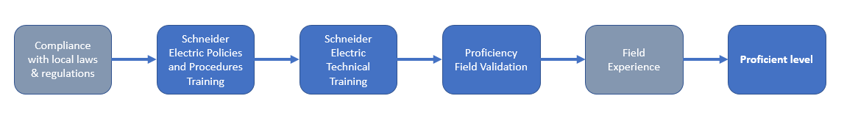

A Partner Technician can perform eligible services only on the product family/range for which he/she has achieved Proficiency.

Eligible services -or service activities- include, but not limited to:
- Installation, start-up & commissioning;
- Fault diagnosis and part identification;
- Preventive maintenance;
- Break & fix activities, including failed part replacement;
- Microcode upgrades.

All Partner Technicians registered to attend a technical training mentioned in this Program Guide must comply to the applicable laws and regulations of the Partner’s country in particular those related to working with electrical and/or cooling equipment. The Partner must provide relevant certificates to Schneider Electric prior to register any of its employees for training.

4.8.2 Schneider Electric Policies and Procedures Training
This 8-hour instructor-led training is mandatory for all Partner Technicians prior to attend any product-related trainings proposed by Schneider Electric to its partners.

In this course, the participants will acquire the knowledge of risk factors for electrical injuries, preventive measures to reduce those risks, safety controls in place for Schneider Electric, and emergency response for electrical accidents and injuries.

Upon completion of this training, the Partner Technician should be able to:
- Describe Schneider Electric’s core beliefs about safely working with potentially energized equipment
- Identify risk factors for and the potential effects of both
  - Electric Shock
  - Arc Flash & Arc Blast
- Connect electrical safety controls and preventive techniques to each type of electrical safety risk
- Describe in detail the factors that must be considered and addressed during a site evaluation and pre-job meeting
- Define emergency response procedures for electrical accidents and injuries

Depending on your location, this training may be delivered at the Partner’s premises or at Schneider Electric’s premises, locally or at a Regional Training Center. Partner Technicians are expected to successfully pass the related test to be able to pursue their training path.

Because Schneider Electric believes it is of the utmost importance that the Partner’s employees are treated with the same level of care as its own employees, this training is free of charge for the Partner Technicians. Travel and accommodation costs for the Partner Technicians are the responsibility of the Partner.

Once a Partner Technician has successfully completed the Schneider Electric Policies and Procedures Training, he/she can be registered in a product training path (see example in the following paragraphs).

Product training paths are regularly updated by Schneider Electric and will be communicated to the Partner by his Schneider Electric contact. It is important to note that depending on the product, it may be necessary to first attend and complete some base and/or other product technical training. In general, training on high-end & complex products will require training on simpler or low-end products as a prerequisite.

4.8.3 Training Curriculum for Power Products
Below is an example of the current training paths for the various UPS product trainings and the corresponding prerequisites. The Partner should ask the Schneider Electric contact for the latest Partner Training Guide including the latest course offering as well as curriculum by product.
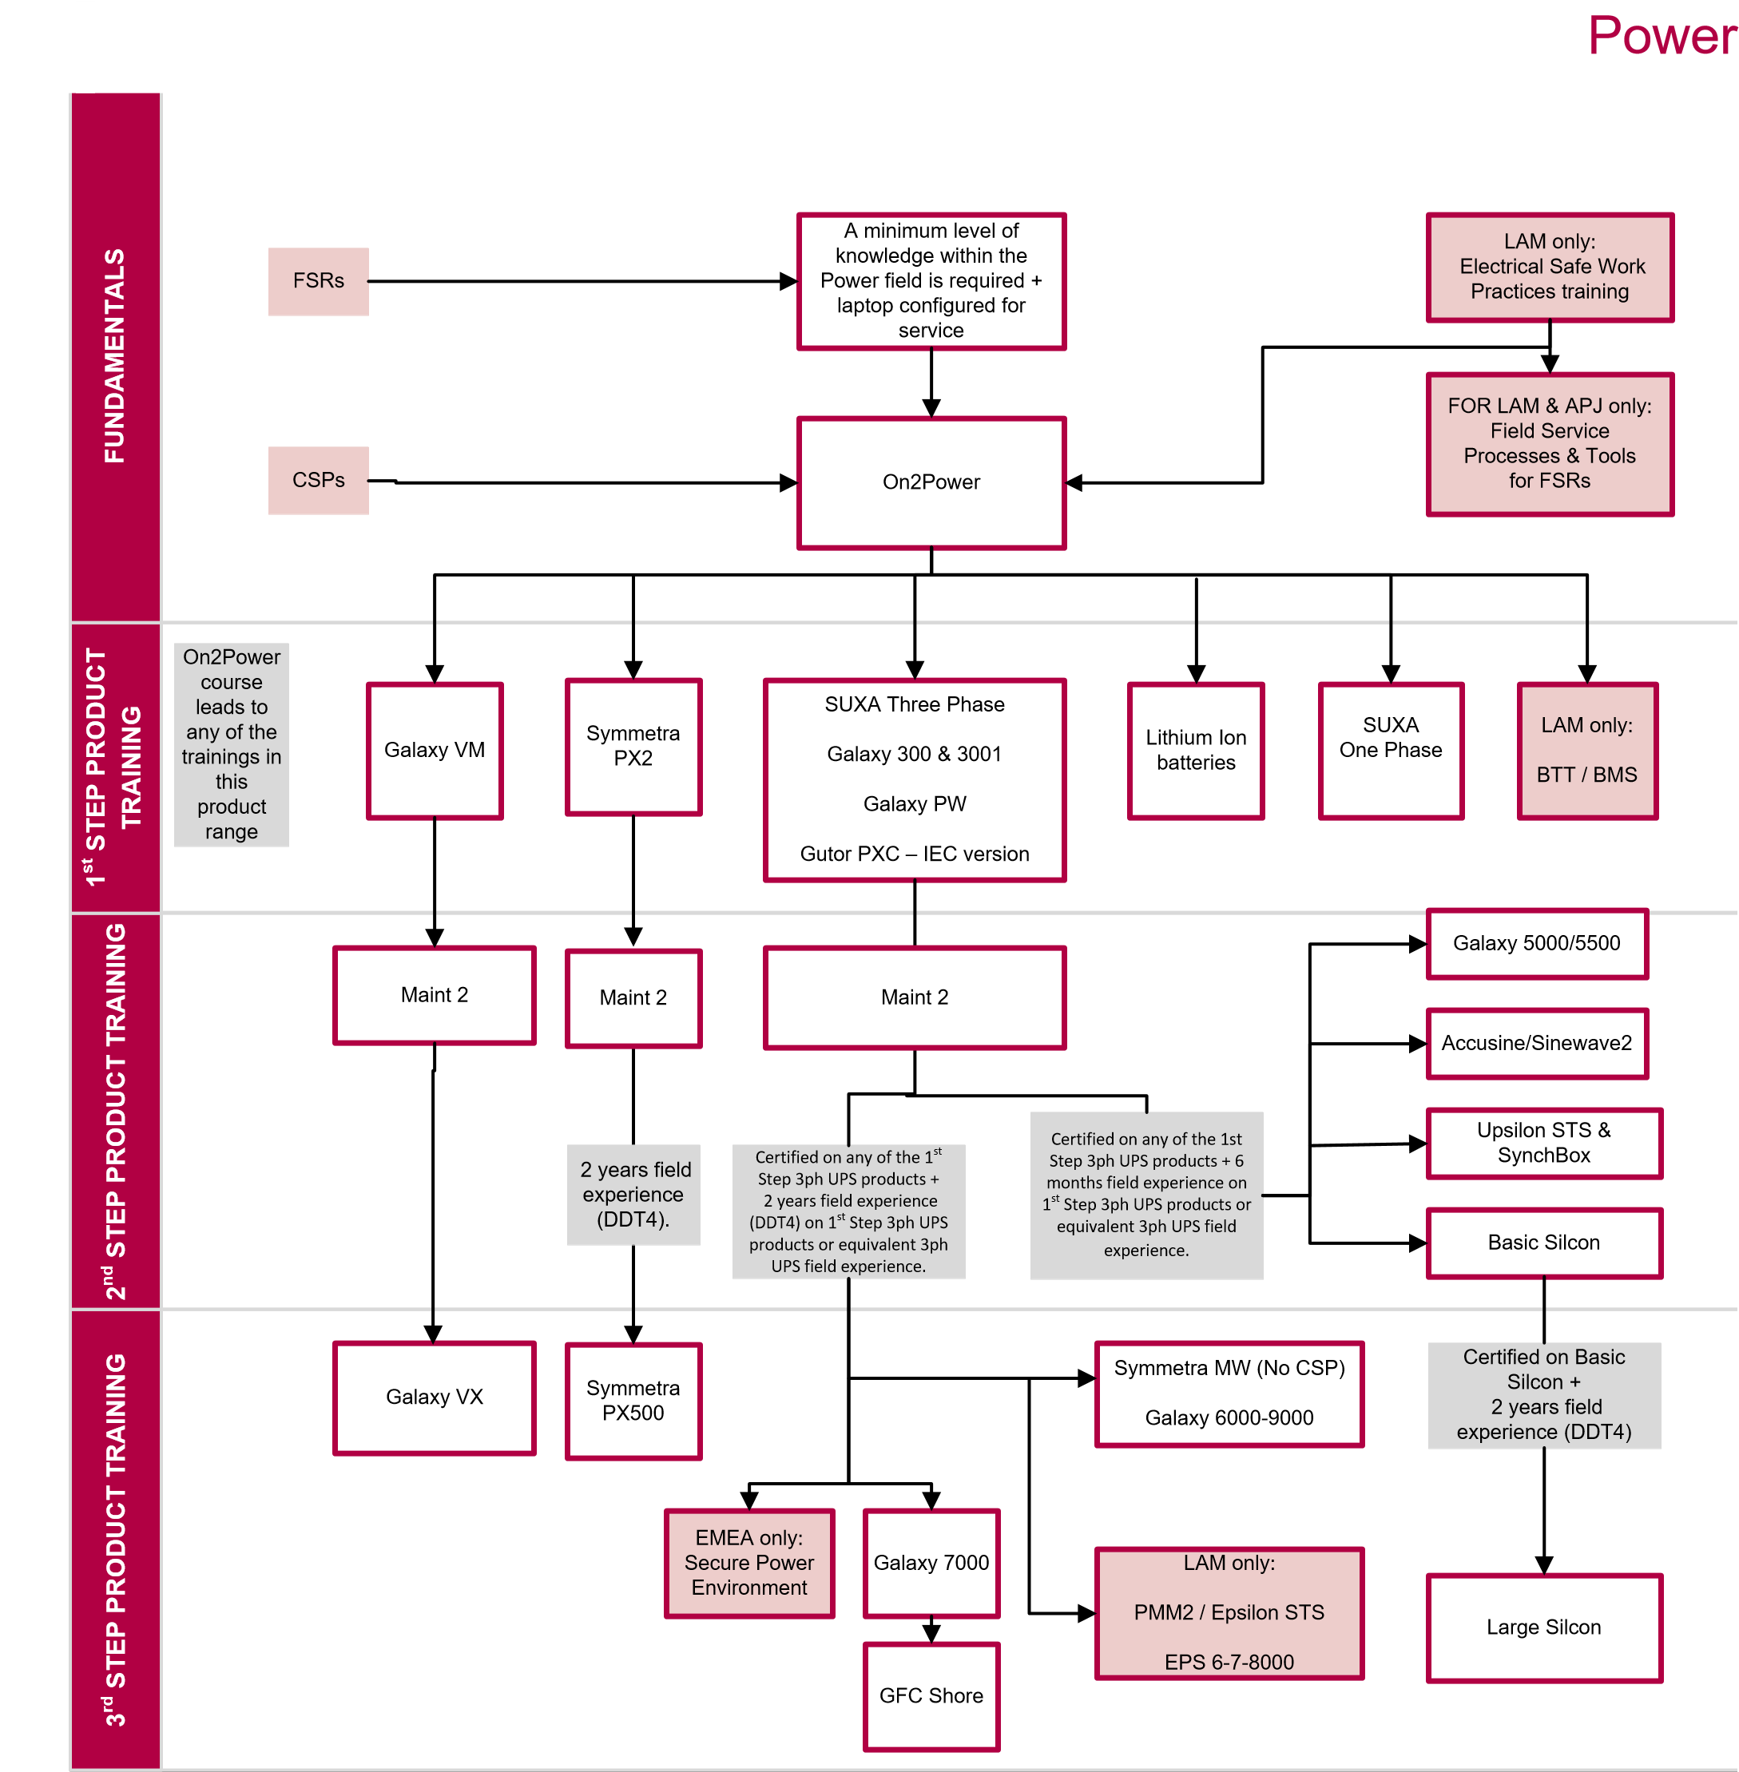

4.8.4 Training Curriculum for InRow Cooling Products
Below is an example of the current training paths for the various cooling product trainings and the corresponding prerequisites. The Partner should ask the Schneider Electric contact for the latest Partner Training Guide including the latest course offering as well as curriculum by product.
Compliance to local regulations regarding HVAC certifications is a mandatory prerequisite for any Partner Technician willing to register to one of the offer trainings.
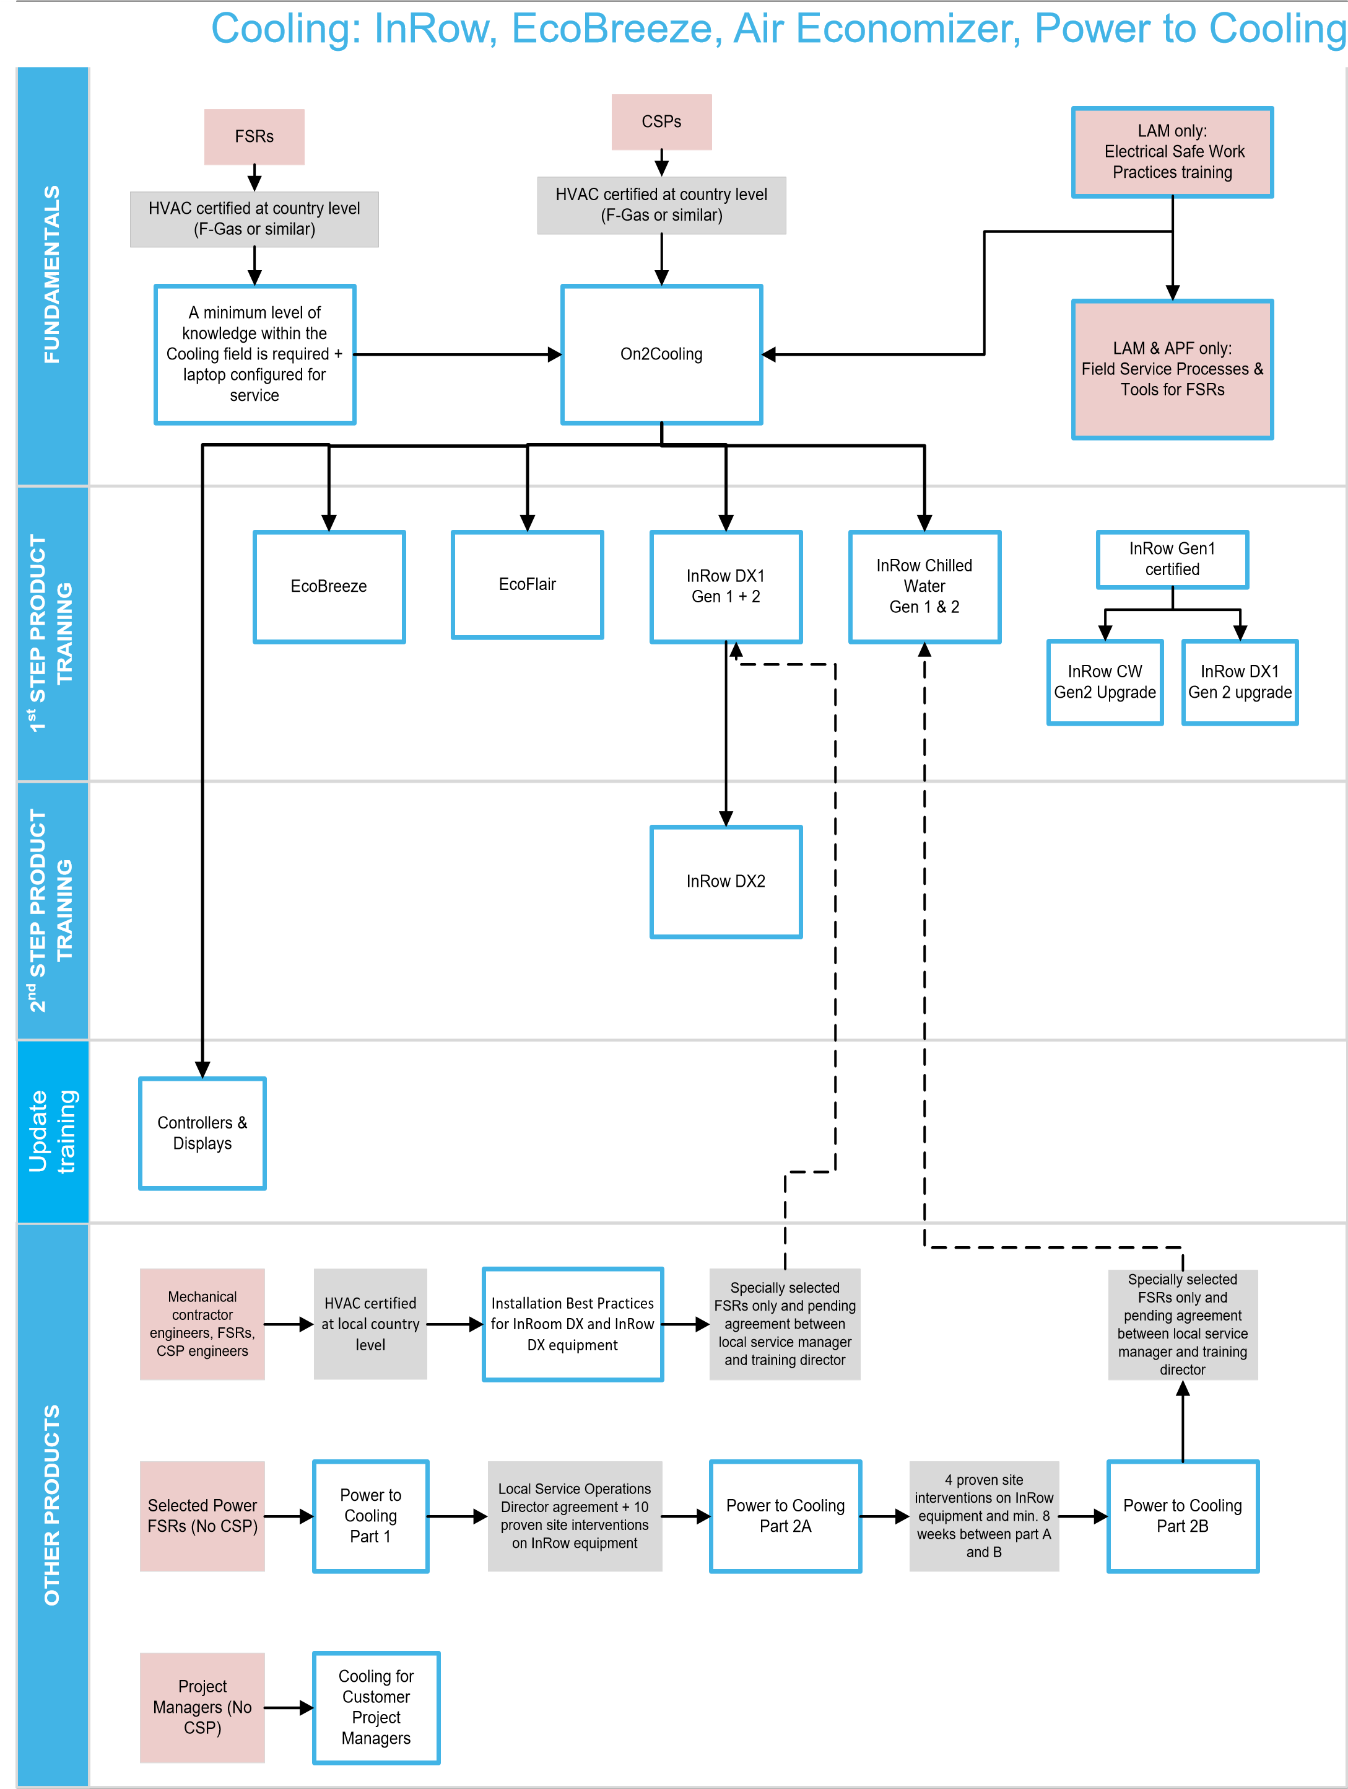

4.8.5 Training Curriculum for InRoom Cooling Products
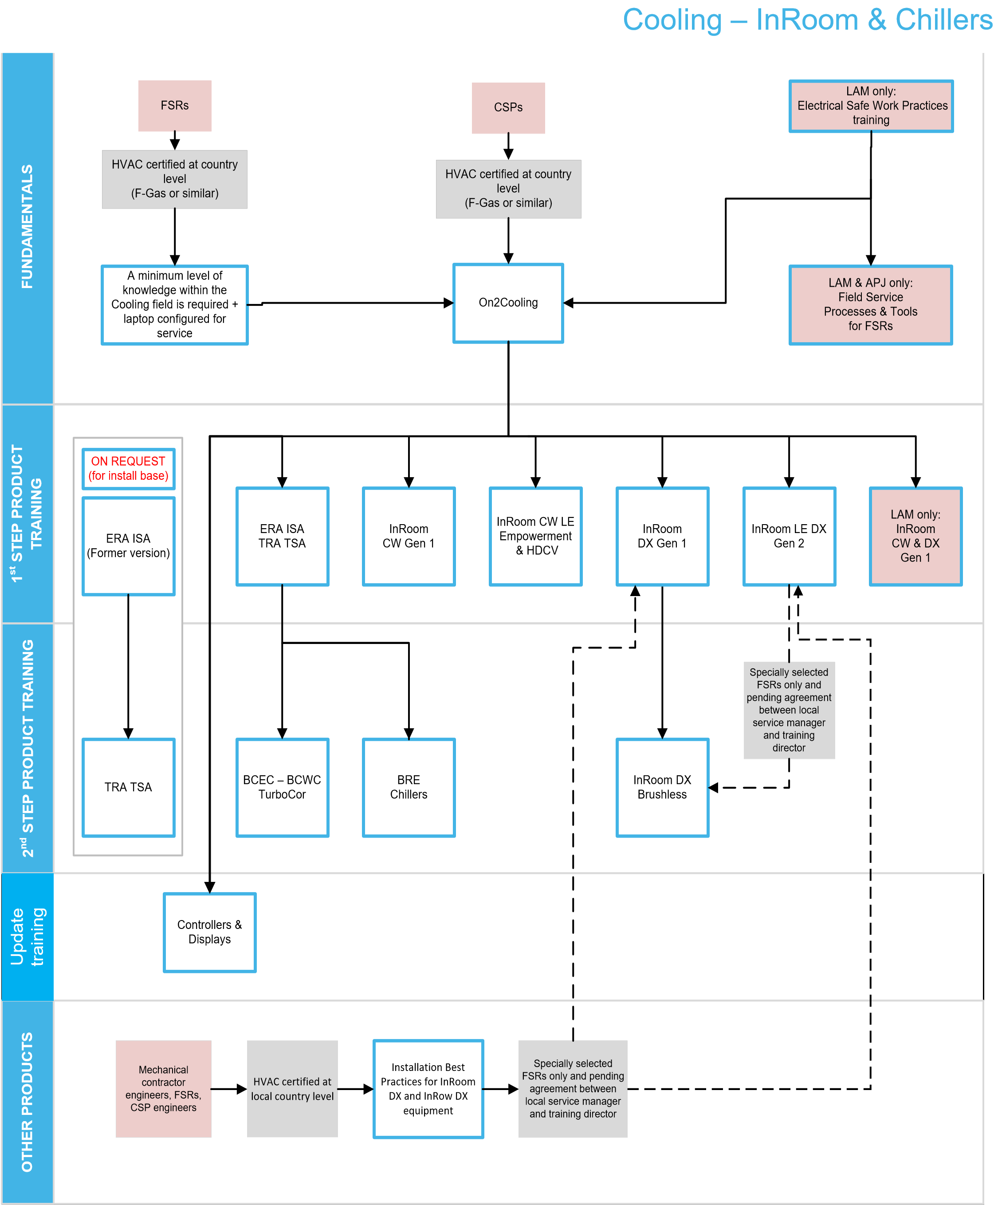
Below is an example of the current training paths for the various cooling product trainings and the corresponding prerequisites. The Partner should ask the Schneider Electric contact for the latest Partner Training Guide including the latest course offering as well as curriculum by product.
Compliance to local regulations regarding HVAC certifications is a mandatory prerequisite for any Partner Technician willing to register to one of the offer trainings.

4.8.5.1 Fast Track On2Cooling
Schneider Electric recognizes that employees from companies with proven track records in the cooling/HVAC world may not need to go through a number of basic concepts offered in Schneider Electric training courses.
For this purpose, Schneider Electric may propose to Partners who qualify to some standard requirements to have their designated employees go through the Fast Track On2Cooling assessment.
This assessment is a [2-hour] written test that will evaluate the candidates’ knowledge of cooling concepts and best practices. A passing score will enable the candidates to attend the [2-day] Fast Track On2Cooling training instead of the standard [4-day] On2Cooling training.
Successful attendance of On2Cooling or Fast Track On2Cooling is a mandatory prerequisite to register candidates to any of the product dedicated trainings.

4.8.5.2 Installation Best Practices for InRoom DX and InRow DX Equipment
Installation is a critical phase in the successful deployment of an InRoom Cooling solution, more so than for many other product types such as power systems. Failure to respect the manufacturer’s recommendations or project specifications, or lack of quality in the execution of assembly, welding or gas-filling may be undetected at first yet result in severe failures and/or damages for the equipment in the future.
For this purpose, Schneider Electric has designed an elective Installation Best Practices for InRoom DX and InRow DX Equipment training course. This course is targeted at the individuals who will perform the installation. Such individuals may be Partner employees or employees of a third party contracted by the Partner for this task.
It is in the best interest of the customers, the Partner himself and Schneider Electric that only people who have successfully completed this training are employed to install InRoom Cooling products and solutions.
In case the Partner decides to use a contractor instead of its own trained personnel for the installation, the Partner should in priority contract with companies with appropriately trained personnel and, if those are not available locally, insist that the selected company trains its personnel with Schneider Electric prior to the actual installation.
Schneider Electric Channel Representative can provide the Partner with the list of contracting companies with trained personnel in the country, and will be able to assist if further training is required for other contractors.

4.8.6Registration for Training and Applicable Charges
The Partner should direct all requests to register a Partner Technician to its Schneider Electric contact, who will validate the request as aligned with the agreed joint business plan between the Partner and Schneider Electric.

Once validated, the Partner will issue a Purchase Order to Schneider Electric for the value of the training selected.

Cost of the Schneider Electric trainings is 500 Euros per person and per day, and does not include travel & accommodation.

Upon successful completion of the course and once payment by the Partner has been completed, the Partner will receive a certificate of course attendance for the relevant individual. In addition, and depending on the completed course, the Partner may receive a code for a one-year license for a proprietary Schneider Electric software tool such as MAINT or Tuner. Each license is nominative and the corresponding tools should only be used by the individual who completed the training.

Renewal of this license on a yearly basis is subject to:
- the Partner still being part of and compliant to the Services Associate Program;
- the correspond individual still being an employee of the Partner and having maintained his/her qualification;
- the payment of a yearly license fee by the Partner to Schneider Electric.

Information on the Schneider Electric software tools and their conditions of used are detailed in a subsequent chapter.

4.8.7 Proficiency Field Validation
Although training is a necessity to ensure the Partner Technician has acquired the correct knowledge of Schneider Electric best practices, tools and standards as well as services operations, he/she will be qualified as Proficient only after a field validation.

Within 3 months of the completion of the product training curriculum and for the first installation/start-up/commissioning performed by the Partner Technician, the Partner will be required to purchase from Schneider Electric a Field Validation service, whereas Schneider Electric will send an experienced representative to verify that the Partner Technician correctly applies at the end-customer sites all the practices and procedures learnt during training.

This Proficiency Field Validation service will be charged atZAR 10000 per day plus travel& accommodation costs as applicable depending on location of the end-customer site.

Upon successful completion of the installation/start-up/commissioning performed by the Partner Technician, the Schneider Electric representative will issue a validation document.

This step must be completed for each individual and for each product family for which the Partner wishes to obtain proficiency.

It is the responsibility of the Partner to ensure that Proficiency requirements are met for all products and individuals for which and with whom the Partner expects to be performing service activities on behalf of Schneider Electric.

4.8.8Field Experience
Final validation of the Partner Technician proficiency on a specific product line will be obtained through experience of service activity performance in the field.

It is expected that within 6 months of completing the training requirements, the Partner Technician will have to complete a minimum of 5 service activities such as described in chapter 4.8.1. Measurement will be based on the submitted activity reports as described in relevant chapter hereafter.

4.8.9 Maintaining Proficiency
Proficiency for a given individual on a specific product line is valid for two years following the validation date. After this period and at least every two subsequent years, Schneider Electric will conduct an individual assessment for each Proficient Partner Technician, and for each relevant product line.

Schneider Electric may also at its convenience conduct random assessments, at no charge for the Partner, either at end-customer site, Partner premises or any other suitable location.

A successful assessment means that the individual proficiency is prolonged for another two years.

In case the assessment is considered as failed for the Partner Technician, the individual will have to attend a refresher training, at the Partner’s expense, as per Schneider Electric’s then recommendation, and may be required to follow the validation track once again.

4.9 Key Performance Indicators for Service Performance
As a subcontractor of Schneider Electric for the performance of service activities included in the Schneider Electric service offer portfolio, it is critical that the Partner maintains at all times the highest level of quality and professionalism in the execution of the activities.
In order to achieve this goal, the Partner agrees to comply with the below KPI targets:
Delivery KPIs (to be chosen from the below)
- Customer Satisfaction
  - Customer satisfaction when worked with Partners
- Productivity:
  - Reports attachment rate
  - Critical Field Services Bulletins (FSB) implementation
  - Safety KPI (audits, FSR trainings, serious incidents)
  - Installed base tracking
  - Lead time to operate
  - Backlog (executed-remaining)
  - Compliance with SLA
Upon joining the Program, the partner is expected to reach the KPI targets within 18 months, after which the review is done on an annual basis.
Non-compliance to the KPIs for Service Performance will prevent the Partner from benefiting from the Year-End Bonus as described in chapter 3.4.2 and may preclude renewing eligibility to the Program.

4.9.1 Customer Satisfaction
Upon completion of a service activity, the Partner must submit a report to Schneider Electric as per chapter 4.11.
Schneider Electric then reserves the right to enter the end-customers’ contacts into its customer satisfaction measurement process in order to measure the perceived quality of the Partner’s work as the end-customers themselves.
It is expected that the Partner will achieve a score of 80% or higher to be compliant.

4.10 Tools & Software Licenses
In order to complete the service activities in line with Schneider Electric best practices, the Partner will need to use, in addition to standard tools and personal protection equipment, specific software tools designed to configure and maintain Schneider Electric products. For critical power and cooling products, Schneider Electric has developed to sets of tools.
- MAINT Tool
- TUNER tool
These tools are proprietary tools and are only available to Proficient Partner Technicians. They are configured by product line: the Partner Technician will only have access to features related to product lines for which he/she has achieved proficiency.
Both tools require that the Partner Technician is equipped with a laptop, as well as a valid license to be renewed on a yearly basis. Licenses are provided on an individual basis and should not be shared with or used by other person than the Proficient Service Representative to which they have been granted.
Costs for tool licenses, personal protection equipment and laptop are the responsibility of the Partner.
The Partner will need to provide its Partner Technicians with all tools and equipment required to perform their duties on behalf of Schneider Electric. The Partner must further ensure that all tools and equipment are kept serviceable and calibrated to manufacturer and industry standards.
All calibration and testing records must be maintained throughout the Partner’s association with the Program and must be made available to Schneider Electric should we wish to review these records.

4.10.1 Communication Equipment
A laptop computer must be included among the tools supplied to each Partner Technician. The laptop is essential because it allows them to interface with most of Schneider Electric’s installed equipment, obtain equipment logs, and perform other service activities such as using MAINT and TUNER tools, as well as generate activity reports.
It should be noted that issues have been experienced with technicians using touch-screen tablet devices, so these types of devices should NOT be used at this time.
System Requirements:
- Windows-based laptop with at least 1 GB of RAM
- Windows 7 or higher operating system
- Keyspan or Tripp Lite USB-to-serial converter (should the laptop not have a serial port)
- One COM port available
- Network (10base-T) card or adapter installed
- CAT-5 network cable for connecting to the Web/SNMP card, checking the alarm log and inspecting variable trending information.

4.10.2 Safety Equipment
Partner personnel tasked with performing service on electrical or electrically operated equipment must be equipped to perform lock out/tag out functions as needed. Appropriate equipment must also be provided to personnel who deal with refrigerants and other potentially harmful materials.
The Partner is responsible for providing all of the necessary safety equipment and personal protection equipment for their Partner Technician, as specified by the country standardized rules and/or regulations governing the type of work they will be performing on behalf of Schneider Electric. The Partner must also have a program in place to ensure all items of safety equipment are fully tested and rotated in accordance with the local laws and regulations.
If requested by Schneider Electric, the Partner will be required to present documentation that clearly proves the safety items used by its Partner Technicians meet the specified requirements for care and test intervals.

4.10.3 MAINT Tool
MAINT provides manufacturer-level guidance and authorized processes for the Partner to complete a set of service activities. Through a connection to the USB service port of the product and to a scope meter, this tool enables the following activities to be completed:
- Assembly
- Start-up
- Control visit
- Break fix
- Maintenance
- Harmonic audit
For each activity, MAINT will propose a step-by-step instruction set and will be able to generate a detailed report. MAINT can be customized to include the Partner logo in the reports.
Reports must be shared by the Partner with the end-customer for signature, with a copy to be systematically transmitted to Schneider Electric in electronic format, whether the corresponding activity is compensated by a fee or not. Schneider Electric thus keeps track of all activities and ensure that customer satisfaction is captured and maintained at all time.
As and when the Partner Technician achieves proficiency on more product lines, additional licenses will be granted to expand the capability of the MAINT tool installed on the Partner Technician’s laptop. Those licenses are not transferable and the tools should only be used by the relevant Partner Technician.

4.10.4 TUNER Tool
The TUNER family tool allows full access to set-up and diagnosis screens for a given product family. Once installed on the Partner Technician’s laptop and through the product services USB port, the tool allows the Partner Technician to:
- Customize products to match with customer specific conditions of use via advanced settings;
- Find issues root causes and anticipate failures via advanced status, alarms and event logs access;
- Keep customer products at the highest availability and quality level thought check-up and updates;
- Benefits to the efficient help of L2 support by forwarding all product key data via a simple click (technical report including event logs, status, alarms, settings);
As and when the Partner Technician achieves proficiency on more product lines, additional licenses will be granted to expand the capability of the TUNER tool installed on the Partner Technician’s laptop. Those licenses are not transferable and the tools should only be used by the relevant Partner Technician.

4.10.5 Tool License Fees
Initial license costs for MAINT and TUNER are included in the product-related technical training costs.
The Partner is required to renew on a yearly basis all MAINT and TUNER licenses used by its Proficient Partner Technicians throughout the duration of the Program.
The price to the Partner is set at: ZAR 12 500 per license per product range and per year.
If a license is not renewed, the tool will no longer be available for the Partner Technician to use.

4.10.6Software Tool Eligibility and Usage
Software tool licenses are made available only to Partner Technicians who have successfully completed the appropriate product technical training as detailed in chapter 4.8.
Each license is individual and it will be required that the Partner Technicians accept the End-User License Agreement (EULA) prior to install and use the tools on their laptops.
No other person than the relevant Proficient Partner Technician may use the tools to perform service activities, and it is the responsibility of the Partner to enforce usage compliance within its organization.
Eligibility to MAINT and TUNER tools is at the sole discretion of Schneider Electric, and may be revoked at any time if Schneider Electric believes that the Partner is in breach of compliance to the present Program and/or to Schneider Electric’s policies and procedures and/or applicable rules and regulations.

4.11 Task Completion Notifications
The Partner must use the reporting features included into MAINT and TUNER tools to adequately generate a report following the completion of a service activity. The report must be shared and acknowledged (or signed in case of printed reports) by the end customer, and a soft copy of report must be shared with Schneider Electric.

4.12 Technical Escalations
In case the Partner requires assistance from Schneider Electric during the performance of a service activity, it is recommended to contact the Customer Care Center (CCC) by phone or e-mail:
[CCC phone number: 0861 300 222 ] [CCC e-mail address: apcsatech@schneider-electric.com]
As a benefit of Services Associate Program, Proficient Partner Technicians can contact directly Level 2 Support from Schneider Electric to obtain free assistance from an expert.
L2 e-mail address: esupport.africaen@schneider-electric.com
Any assistance request or escalation that is not related to a Work Order assigned by Schneider Electric (see 4.13.1) is chargeable and will be charged to the partner at applicable rate based on the time spent by Schneider Electric Level 2 Engineers.

4.13 Service Delivery Fees
For all service activities performed on behalf of Schneider Electric by the Partner under this program agreement and/or detailed in chapter 3.3 Services Delivery Obligations, Schneider Electric will compensate the Partner through the payment of service delivery fees.However, some activities related to implementation of FSBs are not eligible for delivery fees.
Depending on the nature of the service activity, Schneider Electric will either pay a predefined flat fee or a fee based on actual time spent by the Partner to perform the activity.
Flat fees are applicable in particular for activities detailed below and by product line:
- Assembly
- Start-up/Commissioning
- Preventive Maintenance
The applicable fee matrix will be communicated to the Partner every year, and already includes all travel costs.
All fee calculations are based on a standard hourly rate, reviewed on a yearly basis by Schneider Electric, and applicable to all Services Associates in the country.
Applicable taxes such as Value Added Tax (VAT) are applied in addition and in compliance with the country laws and regulations.

4.13.1 Activity Notification & Payment Process
Partner should submit an invoice for all performed activities on a monthly basis, including:
- List of all activities performed including the Work Order number as communicated by Schneider Electric;
- Activity reports / task completion notification with appropriate MAINT report;
- Amounts as per agreed flat fees and/or time spent depending on activity, detailed by activity.
It is important to note that Schneider Electric will withhold any payment related to an activity performed on a system for which Schneider Electric has not received beforehand the full details as in Appendix 2.
Payment by Schneider Electric is governed by the terms included in the Services Associate Agreement signed between the Partner and Schneider Electric.
Example of process for activities performed by Partner and included in an Advantage Service Plan:
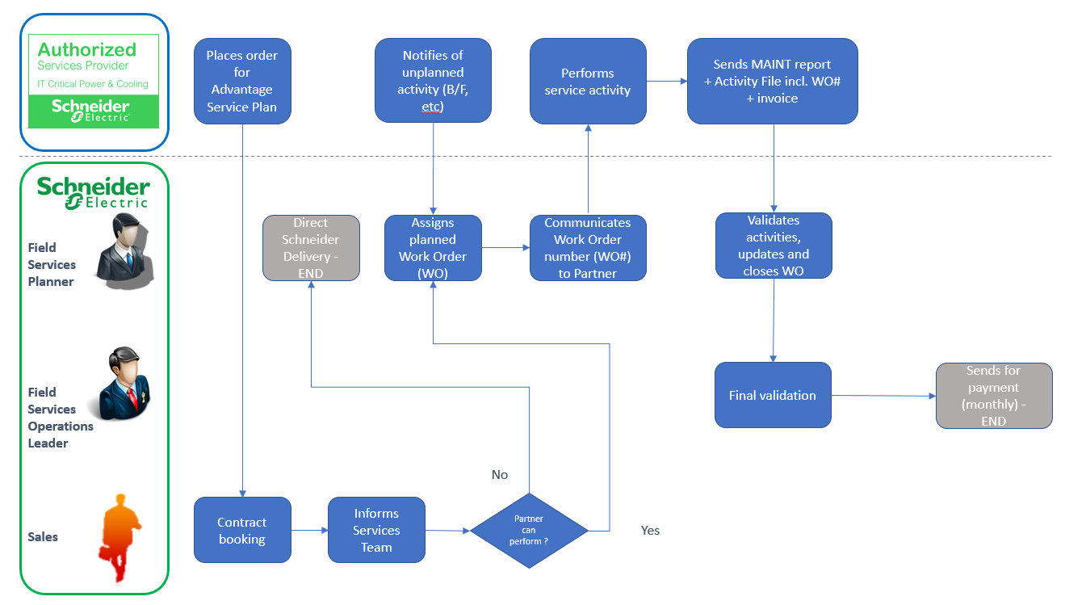
Specific Process when Recertification Preventive Maintenance Visit / Pre-Contract Audit is required
The partner should submit the Recertification Preventive Maintenance visit MAINT report. He will then be notified by Schneider Electric to confirm whether the unit can be placed back under a Service Plan or the unit needs enhancements, upgrades or remedial repair to be performed. It is important to note that the Service Plan will start only once Schneider Electric confirm the asset eligibility.

Appendix 1: Schneider Electric Partner Program Communication Guidelines

Authorized Services Associate Partners should only use the program badge in their communication to the market. The badge has to be applied accordingto the guidelines provided by Schneider Electric and in accordance with the terms of the Partner agreement.
Guidelines may be updated on regular basis by Schneider Electric and will be provided to the Partner upon request.

Appendix 2: Sell-Out Reporting and AssetDeclaration
In order to correctly capture the information related to the assets sold and/or managed by the partner, it is expected that the partner will provide, on regular basis, the detailed information of the assets and the accounts they are installed at. The focus is on serviceable assets such as, but not limited to:
- Power transformers
- MV cubicles and LV switchboards
- LV circuit breakers (> 630 A)
- MV circuit breakers, contactors & switches
- MV protection relays
- MV/LV capacitor banks
- 3 phase UPS
- Single phase UPS (> 5 kVA)
- Cooling products & chillers
- Power Distribution Units (PDU)
- Variable speed drives (VSD)
- Programmable logic controllers (PLC)
- Telemetry PLCs & radio

The scope of required information is detailed below. Your Schneider Electric representative will share the appropriate templates or tools to provide the data.
Partner information | Partner company name | Mandatory
Partner information | Phone | Mandatory
Partner information | Email | Mandatory
Partner information | Related account * | Mandatory
Partner information | Street | Mandatory
Partner information | Postal code | Mandatory
Partner information | City | Mandatory
Partner information | State/Province | Mandatory
Partner information | Country | Mandatory
Account where asset is installed | Installed at (account name) | Mandatory
Account where asset is installed | Contact last name | Mandatory
Account where asset is installed | Contact first name | Mandatory
Account where asset is installed | Contact email | Mandatory
Account where asset is installed | Phone number | Mandatory
Account where asset is installed | Street | Mandatory
Account where asset is installed | Postal code | Mandatory
Account where asset is installed | City | Mandatory
Account where asset is installed | State/Province | Mandatory
Account where asset is installed | Country | Mandatory
Account where asset is installed | Market segment | Optional
Account where asset is installed | Longitude | Optional
Account where asset is installed | Latitude | Optional
Product details | Brand | Mandatory
Product details | Range | Mandatory
Product details | Device type | Mandatory
Product details | Commercial reference | Mandatory
Product details | Name / ID | Mandatory
Product details | Serial number | Mandatory
Product details | Installation date | Mandatory
Product details | Parent product (indicate ID of parent) | Optional
* Ask your Schneider Electric contact for your account ID

Appendix 3: TUNER Software License Renewal Process
- After submitting a purchase order to Schneider Electric South Africa for the license/s to be renewed, go to the link following link: http://licensing.apc.com/pt
2. Choose and download the UPS Tuner of the products you have been trained on. (The default installation directory is D:\MGE UPS SYSTEMS.)
You will be prompted for a log in and a password during download. Use "Partner Download" as log in and "ER854ks3" as password. When you get the confirmation message, you should click the same link to start the download. The site address and log in details are strictly confidential and may not be disclosed to any other individual or company.
3. Launch the software and copy your environment code. (Environment code is unique for your laptop, not unique for the UPS Tuner you want to license)
4. Go back to site, click on “License request”
5. Complete the form
· Choose your area correspondent, (Morne Meintjes)
· Choose the UPS Tuner you want to license,
· Paste in your environment code,
· Type your internal purchase order number,
· Read the "License Contract" and tick "I have read, I understand and I agree with MGE License",
· Submit the form.
· Repeat these steps on each license you are looking for.
· The request approval is then done in France. An e-mail sent to Schneider Electric South Africa to confirm receipt of Purchase Order and on confirmation from Schneider Electric South Africa that a PO has been received for the license being requested, it will be approved.
· The approval process takes around 3-4 working days.
· On approval the license key/s is mailed from France to the mail ID you give in the application form.

Licenses are only valid for a year so they must be renewed on an annual basis. You will receive warnings advising you when the license is due to expire so please act on them as the renewal process does take a few days to complete.
Note: Licenses are issued to an individual person on a specific computer. The license is not transferable and will only be issued to a person who has been certified by Schneider Electric through formal training.

Appendix 4: Product Registration Guidelines
Registration of 3 Phase Power/ Cooling / Management and Monitoring products is mandatory by Schneider Electric’s authorized partner, after equipment startup by them. The registration must be completed within 06 months from the date of invoice for the product, failing which warranty cases will not be entertained. A start-up SKU must be purchased for 3 Phase products to be registered and Factory Warranty initiated.
Partner requests start-up:
- On receipt of a service request it will be registered in the BFO system which is the system used by the company to validate any subsequent warranty claims.
- Start-up registration creates a work order for reference to track the start-up.

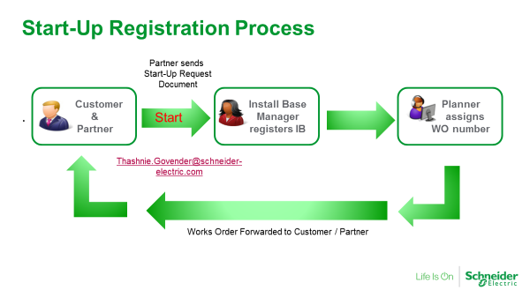
Startup to be performed by Schneider Electric
- thashnie.govender@schneider-electric.comwill provide the work order# (WO-xxxxxxxxxx) number(s) to the Service Partner along with a Pre-commissioning form.
- The pre-commissioning form must be completed by the person responsible for the installation of the equipment and returned to thashnie.govender@schneider-electric.com for verification by the FSR who will be scheduled to do the start-up. Note that the pre-commissioning document must be completed and returned at least 48 hrs before start-up is required to provide sufficient time to validate the information provided.

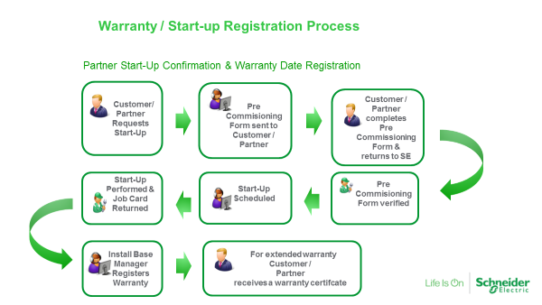
thashnie.govender@se.com will provide the Work order# (WO-xxxxxxxxxx) number(s) to the Service Partner requesting equipment start-up. This WO number should be recorded on the front page of all relevant startup / customer signed reports.
- On completion of the Startup the customer’s signed report is then to be scanned and saved with the file name as given i.e. WO # end user name (WO-xxxxxxxxxx end user name). These files are then to be sent to thashnie.govender@se.com to update the BFO system and initiate warranty.

Startup to be performed by Schneider Electric Associate
- Partner receives the work order and purchase order.
- Partner performs the startup, and returns proof the unit has been commissioned (Job card/startup documents)
- Planner will update the IP date from manufacture date to startup.

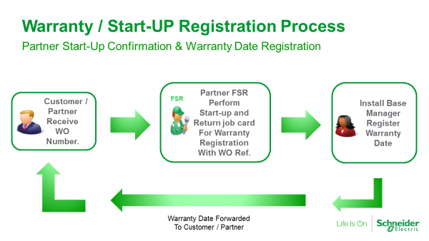

Appendix 5: RMA Process for Equipment Under Factory Warranty
1 and 3 Phase units
• Customer to contact Call Centre or log fault online
• Details to provide: Product part code, Serial #, proof of purchase and a brief description of unit fault
• Call Centre will contact customer and do basic trouble shooting. In order to avoid delays it is important to answer ALL questions raised by the Call Centre

1 Phase:
• Once a fault is confirmed a replacement unit/module will be sent directly to the customer

3 Phase units:
• Once a fault is confirmed a replacement part/unit will be sent directly to the customer
• If the Call Centre requires on site assistance they will contact the local Service team or Service Partner to assist the customer

Call Centre contact details:
• From countries outside South Africa: +27 11 230 5880
• From within South Africa: 0861 300 222
- Select the correct options to go through to the APC by Schneider Customer Care Centre
- First select option 2
- Then option 3
- Then option 1 for 1 phase and 2 for 3 phase

Online Support www.apc.com – select your country

Appendix 6: Warranty Claim on Spares Supplied Without Labor
The following process needs to be followed:
- Contact the Customer Care Centre (+27 11 254 5880) and request an authorization number for the return of the product.
- You will be sent a ‘Warranty Return Request form’. This is to enable the right person to be contacted in case of technical queries, if you do not know all the information requested, just complete what you can.
- A reference number will then be issued to you.
- Return the product to our warehouse clearly indicating this reference number on your delivery note.
- The product will undergo technical investigation to determine the cause of failure.
- If the claim is valid, the product will either be repaired or replaced with a new unit at no cost, in some cases it is possible that a credit will be issued.
- If the claim is invalid, the faulty product will be returned to the Customer at no cost.

Note: Collection of the faulty product will be the responsibility of Schneider Electric.

Appendix 7: Partner Claims
Any services to be performed by the Service Partner on behalf of SCHNEIDER ELECTRIC should be requested in writing with details of what is required to be done, along with the sales order number where the service was purchased from Schneider Electric. If the Service Partner is requesting to perform an activity for which they expect to be paid this request must be authorized by SESA, prior to the service being rendered by the Service Partner. In all cases a works order(WO) number must be provided.
Once the service is completed the relevant documentation (Start-up, Repair etc) must be submitted to Schneider Electric within 5 days of completion.
At the end of each month all claims must be submitted to Schneider Electric in Johannesburg, South Africa by completing the Service Claims Request Form and mailing to thashnie.govender@se.com
Any service performed must be claimed within 3 months of completion. Claims older than 3 months will not be accepted by the company.
Once the claim has been approved by SESA the Service Partner may raise an invoice against:

Schneider Electric South Africa (PTY) LTD
Private Bag x139
Halfway House
Midrand
1685
South Africa

Appendix 8: Monthly Claim Form
[to be inserted]

Appendix 9: Training Booking Form
All training requirements to be submitted to SESA by completing a training booking form. Training schedules will be made available to Partner as and when they are published.


Schneider Electric Technical Training Course Registration
Please note we require passport details and business address info to issue a letter of invitation for visa application Terms and Conditions apply to all bookings received.

Course Name
Course Dates |  | City/Location
Delegate company information
Company Name
Street Address, City & Postal Code
Company Account Number with Schneider Electric South Africa
Company Phone Number
Company VAT Number
Delegate’s Manager Name
Delegate’s Manager Cell No.
Delegate’s Manager E-Mail
Delegate personal information
Learner First Name
Learner Surname
National ID No.
Passport No. (Please attach copy)
Dates of prerequisite training completed
Learner Job Title
Learner Cell No.
Learner E-Mail
NOTE:
- Even if training dates are not yet available one can request training to get preferential seating in the next training scheduled
- Training requests to be submitted to stan.vanrensburg@schneider-electric.com and morne.meintjes@schneider-electric.com
- Purchase Orders for training must be received at least 2weeks prior to training start date.
- Cancellations within 2 weeks of the training start date will be subject to a 20% cancellation fee

END OF DOCUMENT

